PHISHING DETECTION EXTENSION - PROOF OF CONCEPT.

Company Name: PhishAway LLP. (Limited Liability Partnership)

USER MANUAL

About PhishAway. PhishAway LLP has developed a state-of-the-art phishing prevention web extension tailored to safeguard your business against online threats. Dedicated to enhancing cybersecurity, PhishAway combines innovative technology with a user-first approach to protect users from phishing attacks and cyber threats. At PhishAway, your digital safety isn’t just our mission—it’s our priority.

Where is it located? The extension operates as a Cloud-based service for optimal flexibility and accessibility.

How to access it: Visit www.PhishAway.cloud. Upon entering the website, users are directed to the home page, which offers a seamless experience with multiple tabs dedicated to provide various services.

HOME TAB

Home Page Features. The main page features a prominent "Get Started" button, allowing users to choose between two powerful scanning options:
- URL Scan:  - Email Text Scan: | 

URL Scan: Analyze suspicious URLs for potential phishing threats.

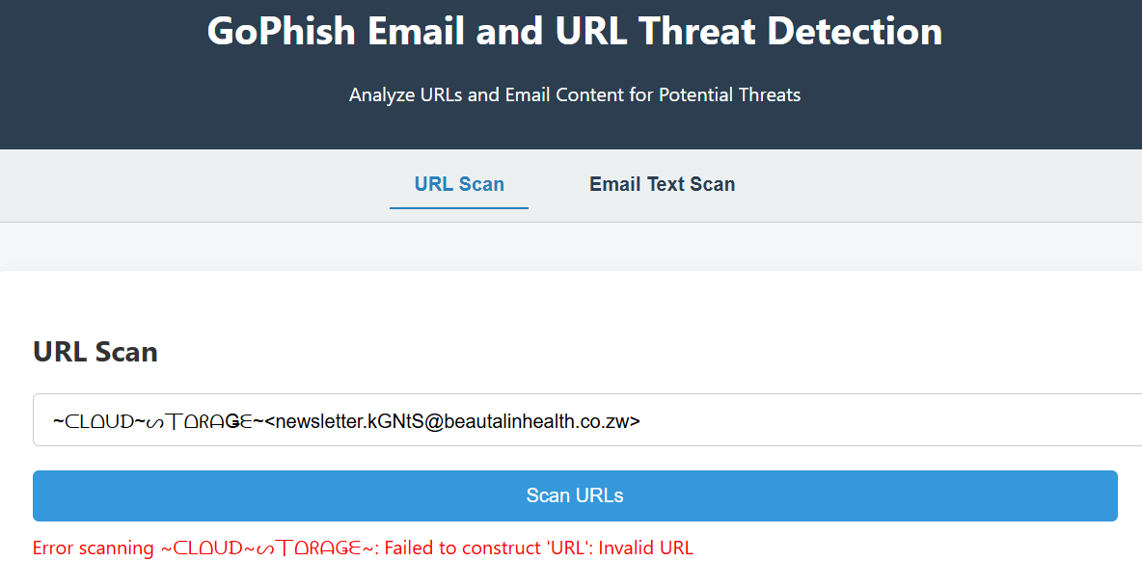

Email Text Scan: Review email content for warning signs of phishing attempts.

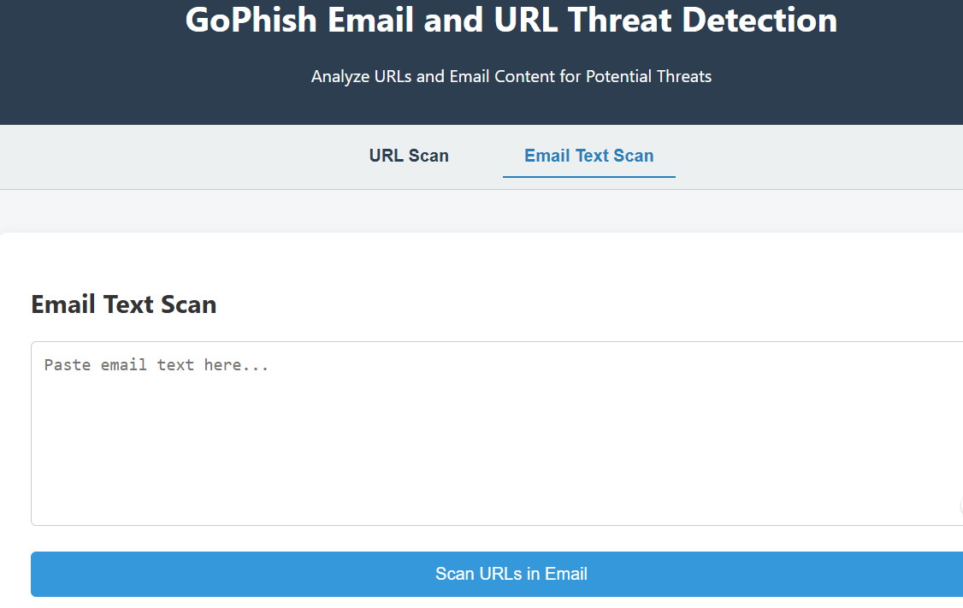 | 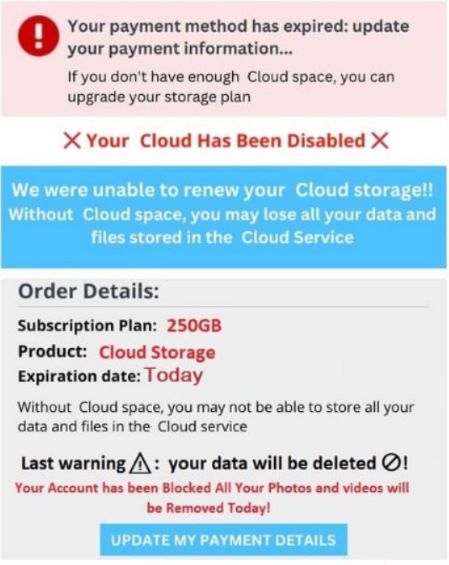

SERVICES TAB

The Services tab provides access to two key features aimed at enhancing your cybersecurity experience:
- Client-Focused Support
- Web Extension Security

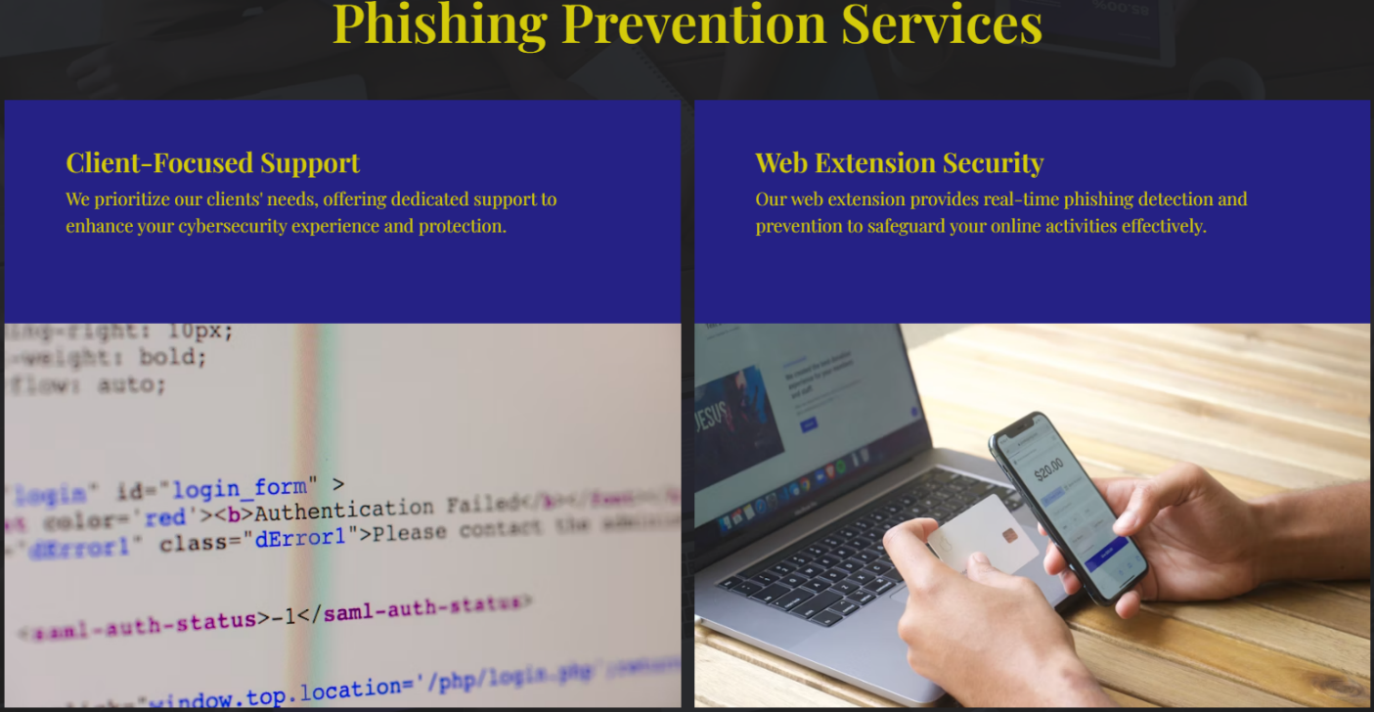

Client-Focused Support. At PhishAway, we prioritize your needs by offering dedicated support to ensure a seamless and secure experience.

Whether you require guidance or assistance, our team is here to help you maximize your protection against phishing threats.

Web Extension Security. Our cutting-edge web extension delivers real-time phishing detection and prevention, safeguarding your online activities effectively.

With this tool, users can navigate the web confidently, knowing their digital safety is our priority.

ABOUT TAB

Your Cyber Shield – PhishAway. PhishAway LLP is your trusted partner in phishing prevention, offering an innovative web extension designed to protect users from cyber threats. With cutting-edge technology and a user-centric approach, PhishAway prioritizes client safety and ensures robust protection against phishing attacks and other digital risks.

Meet the Team. The About Tab highlights the talented individuals behind the PhishAway project, showcasing team photographs, names, roles, and credentials. This section celebrates the collaborative effort, expertise, and dedication that brought this innovative solution to life.

Adding a personal touch, the tab acknowledges the significant contributions of the supervising professor and features the project's successful presentation during the Senior Design Showcase—a milestone achievement in cybersecurity innovation.

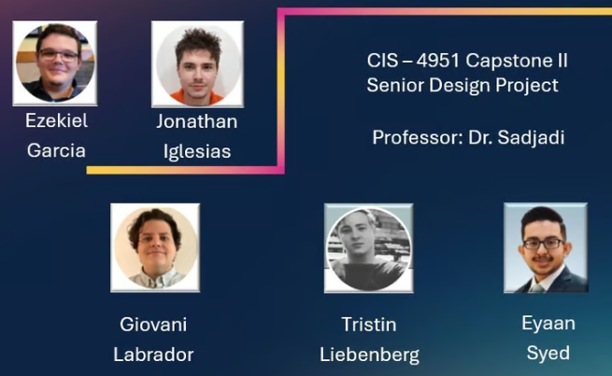

CONTACT TAB

The Contact Tab enables users to easily reach out to the team for inquiries, feedback, or support. To use this feature, follow these steps:

Enter Your First Name: Provide your first name in the designated field to personalize your message.

Input Your Email Address: Enter a valid email address to receive responses from the PhishAway team.

Write Your Message: Share your thoughts, questions, or concerns in the message field. Be as detailed as needed to ensure prompt and accurate assistance.



Once the information is entered, simply click the "Submit" button to send your message. The PhishAway team will review it and respond accordingly.

LINKS TAB

The Links Tab provides quick access to essential resources, including the Phishing Extension Proof of Concept (POC).

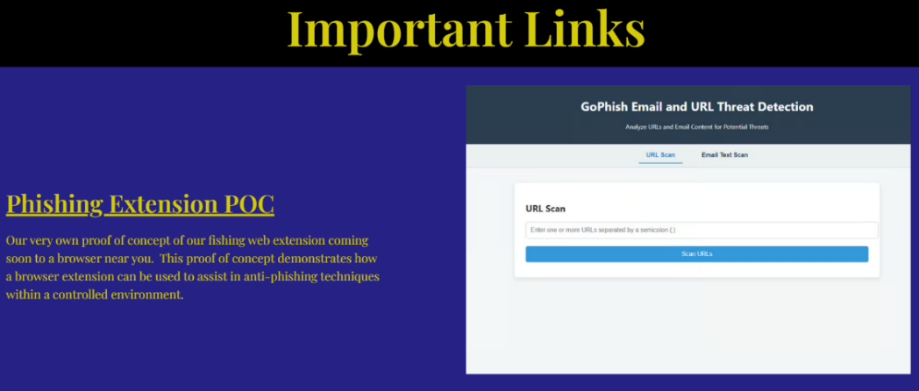

Phishing Extension POC: Discover our exclusive Proof of Concept (POC) for the PhishAway web extension—coming soon to a browser near you. This innovative POC demonstrates how a browser extension can effectively implement anti-phishing techniques in a controlled and secure environment. It showcases the foundational steps toward a future where online safety is just a click away.

Thank you for choosing PhishAway LLP as your trusted cybersecurity partner. This manual has provided a comprehensive guide to understanding and utilizing our Phishing Detection Extension – Proof of Concept. From navigating its tabs to utilizing its features, we hope this manual empowers you to enhance your online safety and combat phishing threats effectively.

For any additional questions or support, please refer to the “Contact” Tab within the extension or reach out to our dedicated support team. PhishAway is committed to ensuring your digital security and protecting your business.

Stay Safe, Stay Secure – With PhishAway!

